Element | Absent | Other Observations
Cranium
Vault
Basicranium
Facial
Mandible
Teeth

Axial Skeleton
C1
C2
C3-7
T1
T2-9
T10-12
L1-4
L5
Sacrum
L Ribs
R Ribs
Unsided Ribs
Left Arm
Clavicle
Scapula
Humerus
Radius
Ulna
Hamate
Capitate
Pisiform
Lunate
Trapezoid
Trapezium
Triquetral
Scaphoid
Metacarpals
Phalanges Proximal
Phalanges Intermediate
Phalanges Distal
Left Leg
Innominate
Femur
Patella
Tibia
Fibula
Cuboid
Talus
Calcaneus
Navicular
Medial Cuneiform
Intermediate Cuneiform
Lateral Cuneiform
Metatarsals
Phalanges Proximal
Phalanges Intermediate
Phalanges Distal
 | Right Arm
Clavical
Scapula
Humerus
Radius
Ulna
Hamate
Capitate
Pisiform
Lunate
Trapezoid
Trapezium
Triquetral
Scaphoid
Metacarpals
Phalanges Proximal
Phalanges Intermediate
Phalanges Distal
 | Right Leg
Innominate
Femur
Patella
Tibia
Fibula
Cuboid
Talus
Calcaneus
Navicular
Medial Cuneiform
Intermediate Cuneiform
Lateral Cuneiform
Metatarsals
Phalanges Proximal
Phalanges Intermediate
Phalanges Distal
 | Other
Hyoid
Sternum
Sesamoids

SKELETAL INVENTORY HOMUNCULUS

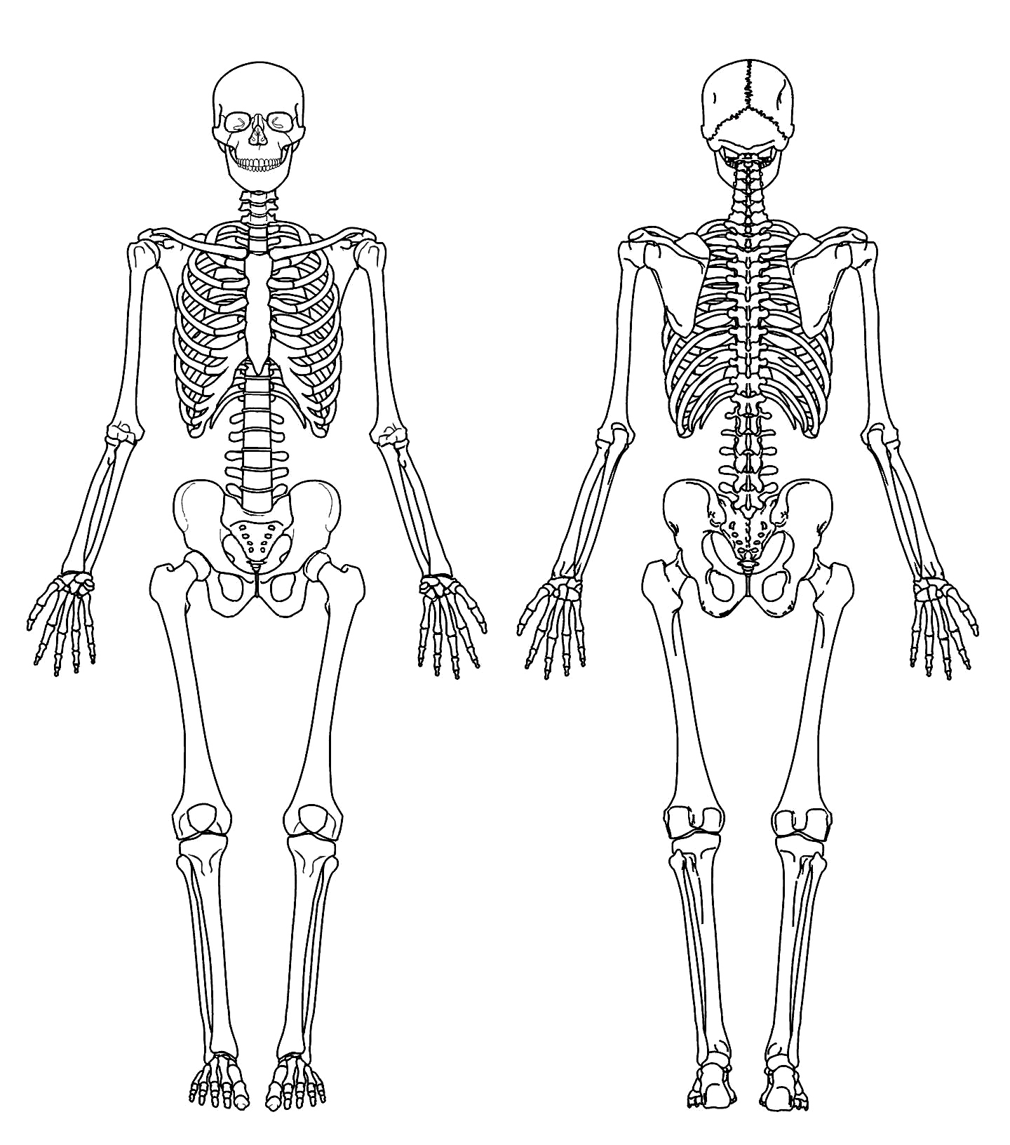
Shaded area represents elements
Present
Absent

CIL Analyst Signature or Initials
Date Analysis Started Date Analysis Ended Page of
Instruments/Equipment Used (Type and ID#)
Exemplars Used

GENERAL OBSERVATIONS

General Observations Notes (Please provide a summary of elements that are absent and any trauma or pathological indicators you observed)

OSTEOMETRY
Measurement Name |  | Left (mm) | Right (mm)
CRANIAL
1. Max. Cranial Length GOL | SpD
2. Max. Cranial Breadth XCB | SpD
3. Bizygomatic Diameter ZYB | SlD
4. Basion-Bregma Height BBH | SpD
5. Cranial Base Length BNL | SlD
6. Basion-Prosthion Length BPL | SpD
7. Maxillo-Alveolar Breadth MAB | SlD
8. Maxillo-Alveolar Length MAL | SpD
9. Biauricular Breadth AUB | SpD
10. Upper Facial Height UFHT | SlD
11. Minimum Frontal Breadth WFB | SlD
12. Upper Facial Breadth UFBR | SlD
15. Nasal Height NLH | SlD
16. Nasal Breadth NLB | SlD
17. Orbital Breadth OBB | SlD
18. Orbital Height OBH | SlD
19. Biorbital Breadth EKB | SlD
20. Interorbital Breadth DKB | SlD
21. Frontal Chord FRC | SlD
22. Parietal Chord PAC | SlD
23. Occipital Chord OCC | SlD
24. Foramen Magnum Length FOL | SlD
25. Foramen Magnum Breadth FOB | SlD
26. Mastoid Length MDH | SlD
MANDIBULAR
28. Chin Height GNI | SlD
29. Height of the Mandibular Body HMF | SlD
30. Breadth of the Mandibular Body TMF | SlD
31. Bigonial Width GOG | SlD
32. Bicondylar Breadth CDB | SlD
33. Minimum Ramus Breadth WRB | SlD
34. Maximum Ramus Breadth XRB | SlD

OSTEOMETRY
Measurement Name |  | Left (mm) | Right (mm)
38. Clavicle Maximum Length XLN | OB
39. Clavicle Ant.-Post. Diameter at Midshaft APD | SlD
40. Clavicle Sup.-Inf. Diameter at Midshaft VRD | SlD
41. Scapula Height PHT | SlD
42. Scapula Breadth PBR | SpD
43. Humerus Maximum Length XLN | OB
44. Humerus Epicondylar Breadth EBR | SlD
45. Humerus Vertical Diameter of Head HDD | SlD
46. Humerus Maximum Diameter at Midshaft MXD | SlD
47. Humerus Minimum Diameter at Midshaft MWD | SlD
48. Radius Maximum Length XLN | OB
49. Radius Ant.-Post. Diameter at Midshaft APD | SlD
50. Radius Med.-Lat. Diameter at Midshaft TVD | SlD
51. Ulna Maximum Length XLN | OB
52. Ulna Dorso-Volar Diameter DVD | SlD
53. Ulna Transv. Diameter TVD | SlD
56. Sacrum Anterior Height AHT | SlD
57. Sacrum Ant.-Sup. Breadth ABR | SlD
58. Sacrum Max. Trans. Diameter of Base S1 S1B | SlD
59. Innominate Height OHT | SpD
60. Innominate Iliac Breadth ABR | SpD
63. Femur Maximum Length XLN | OB
64. Femur Bicondylar Length BLN | OB
65. Femur Epicondylar Breadth EBR | OB
66. Femur Maximum Diameter of Femoral Head HDD | SlD
67. Femur Ant.-Post. Subtrochanteric Diameter SAP | SlD
68. Femur Med.-Lat. Subtrochanteric Diameter STV | SlD
69. Femur Ant.-Post. Midshaft Diameter MAP | SlD
70. Femur Med.-Lat. Midshaft Diameter MTV | SlD
72. Tibia Maximum Condylo-Malleolar Length* XLN | OB
73. Tibia Maximum Prox. Epiphyseal Breadth PEB | OB
74. Tibia Maximum Dist. Epiphyseal Breadth DEB | OB
75. Tibia Maximum Diameter at Nutrient Foramen NFX | SlD
76. Tibia Max. Med.-Lat. Diameter at Nutrient Foramen NFT | SlD
78. Fibula Maximum Length XLN | OB
79. Fibula Maximum Diameter at Midshaft MDM | SlD
80. Calcaneus Maximum Length CXL | SlD
81. Calcaneus Middle Breadth CBR | SlD

TRAUMA AND PATHOLOGICAL ANALYSIS

Trauma and Pathological Analysis Notes (Provide references where necessary/appropriate)

Instruments/Equipment Used (Type and ID#)

Exemplars Used

Check here if additional notes are on back
Check here if there is a continuation or attachment to this form

GENERAL OBSERVATIONS

General Observations Notes (Provide references where necessary/appropriate)

Instruments/Equipment Used (Type and ID#)

Exemplars Used

Check here if additional notes are on back
Check here if there is a continuation or attachment to this form

TRAUMA AND GENERAL OBSERVATIONS HOMUNCULUS

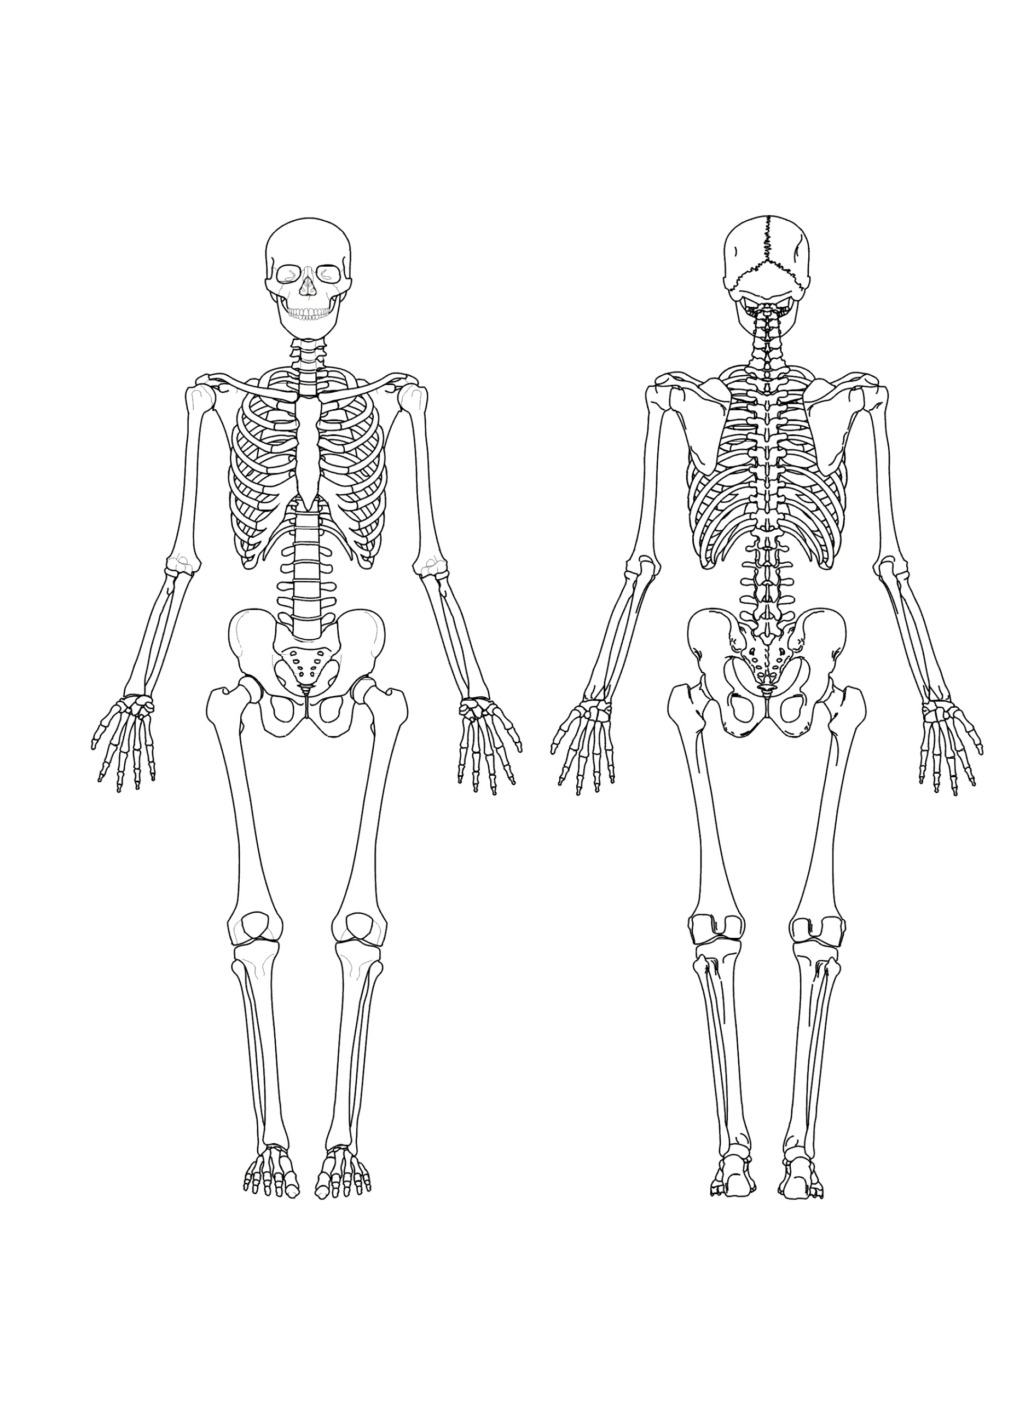

CONTINUATION TO SKELETAL ANALYSIS

ADDENDUM TO SKELETAL ANALYSIS FORMS

Instruments/Equipment Used (Type and ID#)

Exemplars Used

Check here if additional notes are on back
Check here if there is a continuation or attachment to this form

